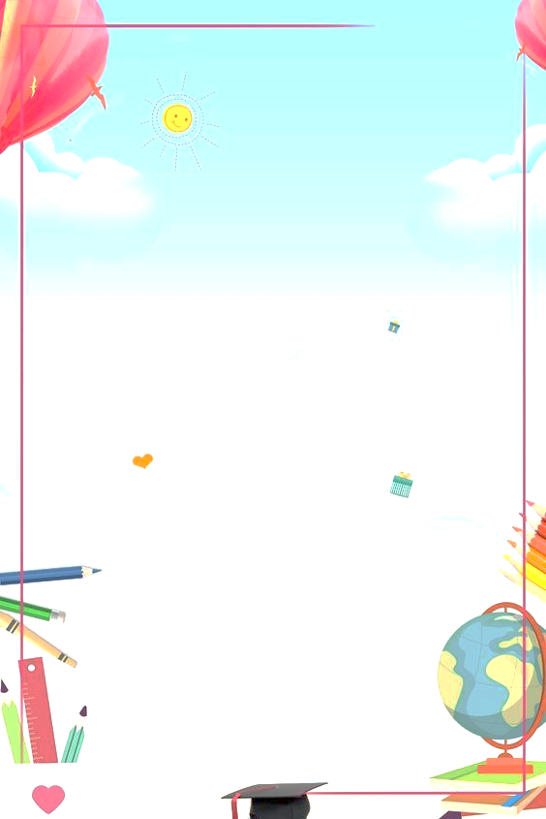
English Language Quiz for Kids
Introduction:
Welcome to the English Language Quiz! Today, we will have fun and test your knowledge with questions, riddles, and puzzles. Get ready for an exciting challenge. Good luck!

Questions:
1. What color is the word "yellow"?
a) Blue
b) Yellow
c) Red

